**Neural Network techniques for Brain Tumor segmentation**

**By: Ashrith munikuntla-180330271**

**A.N.S.R.Tridham -180330055**

**SUPERVISOR : DR.A.PAUL**

**DOMAIN:**

* DEEP LEARNING ( NEURAL NETWORKS )
* BRANCH OF AI

**WHY DID WE CHOOSE THIS DOMAIN?**

* As a part of our research on the project “Restaurant recommendation system” we got interested to solve the real world problems implementing AI and DL algorithms.
* There, we got really enthusiastic about learning and exploring AI at it’s core . Also, as AI is our core subject we’re confident enough to complete this project

**Abstract**

* The introduction of quantitative image analysis has given rise to fields such as radiomics which have been used to predict clinical sequelae. One growing area of interest for analysis is brain tumours, in particular glioblastoma multiforme (GBM). Tumour segmentation is an important step in the pipeline in the analysis of this pathology. Manual segmentation is often inconsistent as it varies between observers. Automated segmentation has been proposed to combat this issue. Methodologies such as convolutional neural networks (CNNs) which are machine learning pipelines modelled on the biological process of neurons (called nodes) and synapses (connections) have been of interest in the literature. We investigate the role of CNNs to segment brain tumours by firstly taking an educational look at CNNs and perform a literature search to determine an example pipeline for segmentation. We then investigate the future use of CNNs by exploring a novel field—radiomics. This examines quantitative features of brain tumours such as shape, texture, and signal intensity to predict clinical outcomes such as survival and response to therapy.

The problem statement:

* The aim of the paper is tumor identification in brain CT images. The main reason for detection of brain tumors is to provide aid to clinical diagnosis. The aim is to provide an algorithm that guarantees the presence of a tumor by combining several procedures to provide a foolproof
* The focus of this project is CT brain images’ tumor extraction and its representation in simpler form such that it is understandable by everyone.
* Humans tend to understand colored images better than black and white images, thus, we are using colors to make the representation simpler enough to be understood by the patient along with the medical staff. The objective of this work is to bring some useful information in simpler form in front of the users, especially for the medical staff treating the patient. Aim of this paper is to define an algorithm that will result in extracted image of the tumor from the CT brain image.
* The resultant image will be able to provide information like size, dimension and position of the tumor, plotting contour and c-label of the tumor and its boundary provides us with information related to the tumor that can prove useful for various cases, which will provide a better base for the staff to decide the curing procedure.

**What are the research issues present till now of the problem?**

* There are websites for the brain tumor detection applications which provide details about the brain tumor, but in those the user cannot register his problem so that the nearby doctors would approach him in some or the other way.
* A person who wants to attend the hospital for the brain Tumor treatment has to go and visit only that particular hospital place physically. This makes him a main problem to travel again and again.
* The existing applications mainly focus on information displaying about the brain tumor and display the details of the hospitals. Most of the applications available provide information only about the problem, there is no classified information about the detection without visiting the hospital.

**The social benefits of our proposed work**

* There is a wide scope for future implementation of “Brain Tumor Detection using Convolutional Neural Networks” towards an interesting experience of modern technologies. Digital Platform is a ‘one stop shops’ for all kinds of Hospitals to serve the domestic and international users at any time, any moment and anywhere in any parts of the world. Not being sticky to make packages within India only, it can be global - a “global platform” through a comprehensive.
* In present days, modern technologies have made treatment more pleasure comprising speed with comfort. So, people are not willing to be bound within only a small geographical area, so there is place to make them experience the taste of “Global Platform”.
* It can be enhanced into a Mobile Application. And also in future we can create an Artificial Intelligence Deep Neural Network Model for the evaluation for all other kind of diseases and even we develop in such a way that all the small kind of diseases can be cured without contacting a doctor and by spending lot of money

**Introduction**

* With the introduction of methods to quantitatively analyze gliomas with computational methods comes a new frontier for radiology. It is important for radiologists to be abreast of advances in machine learning.
* This has been recognized by the recent changes in the Royal Australian and New Zealand College of Radiologists (RANZCR) curriculum that incorporates machine learning into the part I applied imaging technology examinations [[1](https://insightsimaging.springeropen.com/articles/10.1186/s13244-020-00869-4)]. Methods that incorporate quantitative analyses will add to the traditional visual analysis of images.
* An important step in the image analysis pipeline is the anatomical segmentation of regions of interest (ROI), for example, defining a volume of abnormal tissue from a background of normal tissue. This will allow for statistical analysis of features that is not visible by human perception .
* For example, the field of radiomics is fast developing as a method of predicting survival times from imaging features such as shape of a volume of interest and texture and intensity of the voxel habitat. With the development of these methods comes a greater need for automated segmentation. Figure [1](https://insightsimaging.springeropen.com/articles/10.1186/s13244-020-00869-4) shows inconsistencies in blinded manual segmentation of brain tumors by the first and second authors.
* A measure of consistency of image segmentation can be performed by the Sorensen–Dice coefficient, and this was calculated with the Studier Fenster calculator (available at: <http://studierfenster.tugraz.at/>). This ranges from 0 to 1 with 1 having 100% consistency [[3](https://insightsimaging.springeropen.com/articles/10.1186/s13244-020-00869-4)]. The value obtained from the segmentation by the first and second author was 0.91 which demonstrates the discrepancy in manual segmentation.

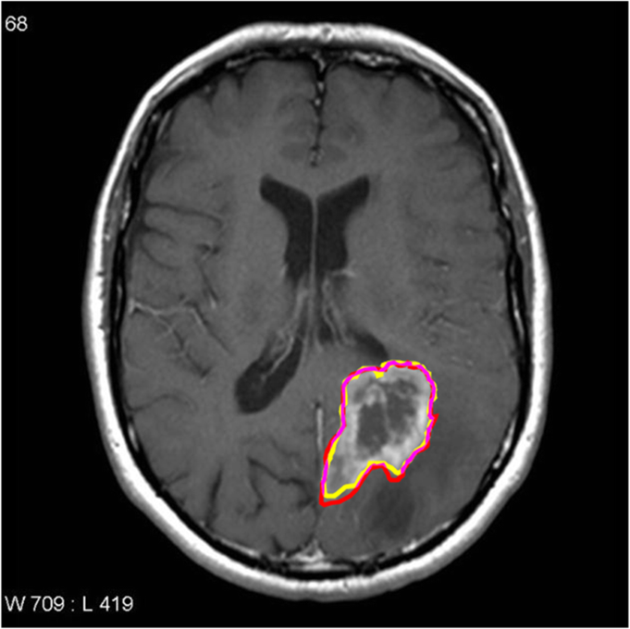

* As an example of machine learning, this educational paper will examine the use of convolutional neural networks for low-grade diffuse astrocytoma (World Health Organization grade 2) and high-grade (World Health Organization grade 4) glioblastoma—also known as glioblastoma multiforme (GBM) segmentation. Convolutional neural networks (CNNs) are a unique machine learning structure originally modelled on the human visual cortex [[4](https://insightsimaging.springeropen.com/articles/10.1186/s13244-020-00869-4)]. The brain was studied due to the abundance of segmentation methods that are already available and well established in the literature [[5](https://insightsimaging.springeropen.com/articles/10.1186/s13244-020-00869-4)]. Machine learning is fast developing and is exponentially being represented at international conferences [[6](https://insightsimaging.springeropen.com/articles/10.1186/s13244-020-00869-4)]. An educational perspective is needed for radiologists. This paper provides a novel balance between education and a state-of-the-art review on convolutional neural networks in glioblastoma.
* To better understand CNNs, artificial neural networks will be reviewed briefly as this is a simple introduction for understanding neural networks such as CNNs. Artificial neural networks involve inputs which feed into a hidden layer which has biases or weightings associated with it and outputs which change as the machine ‘learns’ from a dataset to produce the expected result [[7](https://insightsimaging.springeropen.com/articles/10.1186/s13244-020-00869-4)]. Further details will be provided in this paper.

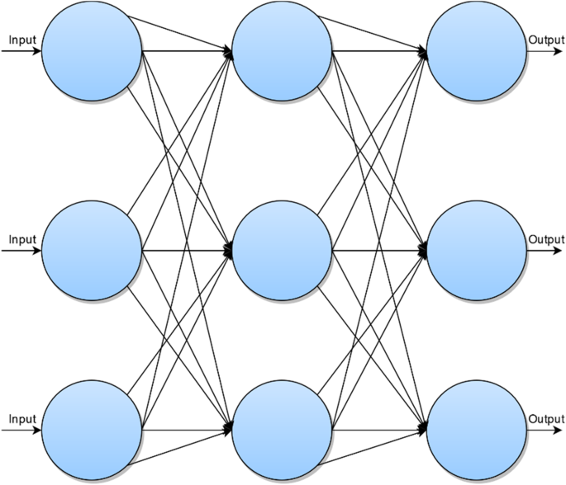

Diagrammatic representation of a convolutional neural network

* From Fig. [2](https://insightsimaging.springeropen.com/articles/10.1186/s13244-020-00869-4), each blue circle represents a node or neuron from which the name ‘neural network’ is derived from. There is an input to each neuron. The arrows or ‘axons’ represent the connection between neurons. The result is an output which generates an approximation of the image which is iteratively refined [[8](https://insightsimaging.springeropen.com/articles/10.1186/s13244-020-00869-4)].
* The nodes receive an initial input from a data source—as seen in Fig. [2](https://insightsimaging.springeropen.com/articles/10.1186/s13244-020-00869-4). This is then fed into the next neuronal layer and given an initial weighting. This middle ‘*hidden*’ layer can be repeated a multitude of times. This is then fed into the output node, and this produced the desired result. However, this needs to be refined further, and one loop or *iteration* is not sufficient for the generation of an optimal output.
* This is where the novelty of a neural network comes in. In order to refine the output of the nodes, the weightings are changed. Thus, through iteration, the nodes are given different weightings. Based on these weightings, the output can changed through each iteration and eventually an output that reaches the desired result can be produced.
* Thus, neural networks provide a means of optimizing an initial data input via weighting certain aspects of the input to produce an optimal result.
* There are various other segmentation methods detailed elsewhere [[9](https://insightsimaging.springeropen.com/articles/10.1186/s13244-020-00869-4)]. Some of the notable segmentation models are:
* **Thresholding method**—as the name implies, voxels above a threshold are classified as belonging to the tumor [[10](https://insightsimaging.springeropen.com/articles/10.1186/s13244-020-00869-4)].
* **Edge-based method**—changes in the intensity between edges of voxels are used as the boundaries of the tumors [[11](https://insightsimaging.springeropen.com/articles/10.1186/s13244-020-00869-4)].
* **Region growing method**—a seed voxel is inputted into the segmentation; from this seed, voxels that are similar are classified as belonging to the tumor [[12](https://insightsimaging.springeropen.com/articles/10.1186/s13244-020-00869-4)].
* **Watershed algorithm**—this is a unique segmentation method whereby the voxel intensities or gradients are represented by a topographical map similar to those seen in geography. Based on the ‘steepness’ of the map, a boundary is assigned [[13](https://insightsimaging.springeropen.com/articles/10.1186/s13244-020-00869-4)].
* **Atlas method**—a tumor free reference MRI is used to segment the MRI containing the tumour volume [[14](https://insightsimaging.springeropen.com/articles/10.1186/s13244-020-00869-4)].

-The advantages of the convolutional neural network are the fact that it provides optimal accuracy of segmentation. However, this is at the cost of computational load [[9](https://insightsimaging.springeropen.com/articles/10.1186/s13244-020-00869-4)]. With advances in computation, the implementation of convolutional neural networks and refinement of the structural segmentation of brain tumors can be enhanced

**Extensive literature survey & Extensive analysis of existing works**

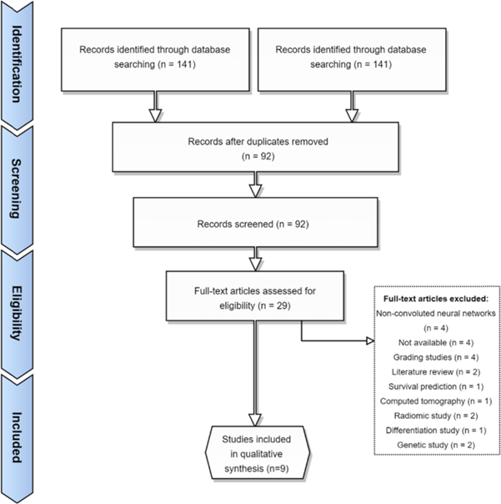

**Fig 5.**

* As per the Preferred Reporting Items for Systematic Reviews and Meta-Analyses (PRISMA), a literature review was performed on Web of Science, Scopus, and PubMed using the search terms: *(neural AND network*) AND (GBM OR “glioblastoma” OR astrocytoma) AND segment\**.
* We found 18 articles from PubMed, 72 from Scopus, and 51 from Web of Science. After duplicates were removed, 92 articles remained. For a broad scope, we included all studies that examined convolutional neural networks in MRI brains the past 5 years. We excluded conference abstracts, non-English papers, reviews, and genomic papers. Microscopy papers were excluded.
* Grading studies and differentiation studies were also excluded on the basis that these studies did not address segmentation directly. After the inclusion and exclusion criteria were applied, 29 studies remained.
* Full texts were reviewed. Four studies were excluded on the basis that they were non-convoluted neural networks, 3 studies were excluded since they were not available, and 3 grading studies, 2 reviews, 2 purely genetic studies, 1 survival prediction study, 1 computed tomography study, 2 radiomic studies, and 1 which looked at the differentiation between different tumours were also excluded. This is summarized in Fig. [5](https://insightsimaging.springeropen.com/articles/10.1186/s13244-020-00869-4).

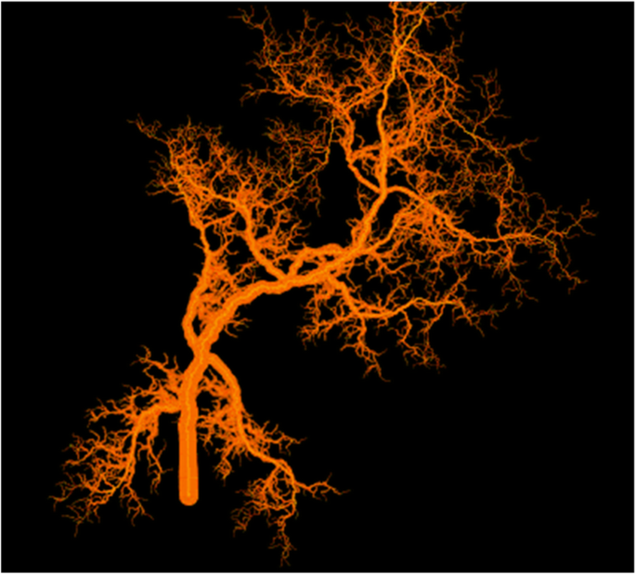

Generation of fractal model of tumor microvasculature through FracLac

In addition to the 9 studies found by the data search, a hand search revealed one additional study [[19](https://insightsimaging.springeropen.com/articles/10.1186/s13244-020-00869-4)]. Therefore, *n* = 10 studies were used in the qualitative analysis.

**Literature findings**

* Convolutional neural networks represent a growing field within the literature. Our search found 10 studies that detailed the methodology of segmentation involving convolutional neural networks. The methodology examined in this review will be divided into subsections relating each step of the segmentation process. The main findings will be reported. An example segmentation algorithm will be proposed based on the findings from the literature. The main output measure is the Sørensen–Dice coefficient (DSC) which is calculated as follows [3]:
* DSC = (2∣X∩Y∣) / (|X|+∣Y∣)
* The *X* represents the cardinal elements in the first set (automatic segmentation set), and *Y* represents the second set—generally the manually segmented set that the automatic segmentation set is tested against. The ⋂ symbol represents where the segmentations intersect. Where the DSC is not reported, the accuracy will be used. Table [1](https://insightsimaging.springeropen.com/articles/10.1186/s13244-020-00869-4) reports the main findings of studies involving CNNs.
* For the training set, most studies used the Multimodal *Br*ain *T*umour *S*egmentation (BraTS) benchmark which is a dataset of manually segmented MRIs containing high-grade and low-grade gliomas set up by the Medical Image Computing and Computer-Assisted Interventions (MICCAI) [[20](https://insightsimaging.springeropen.com/articles/10.1186/s13244-020-00869-4)]. Only one study [[21](https://insightsimaging.springeropen.com/articles/10.1186/s13244-020-00869-4)] used a training set from their own institution. This study negated the need for initial manual segmentation due to using a watershed algorithm which automatically segmented the training dataset. This improved the accuracy of segmentation from 82 to 89% and could be used for the development of future CNNs.
* Specifics of convolution layers (i.e. filtration of images) were not detailed extensively. This is partly because feature extraction involves multiple algorithms and multiple methodologies. For example, Perkuhn et al. [[22](https://insightsimaging.springeropen.com/articles/10.1186/s13244-020-00869-4)] used 53 kernels for feature extraction in four convolutional layers. It would be difficult to summarise such extensive and numerous convolution methodology.
* Overfitting was done in a variety of ways. Three articles did not correct or did not report details of overfitting [[23](https://insightsimaging.springeropen.com/articles/10.1186/s13244-020-00869-4),[24](https://insightsimaging.springeropen.com/articles/10.1186/s13244-020-00869-4),[25](https://insightsimaging.springeropen.com/articles/10.1186/s13244-020-00869-4)]. The majority of overfitting was done via down sampling [[24](https://insightsimaging.springeropen.com/articles/10.1186/s13244-020-00869-4), [26](https://insightsimaging.springeropen.com/articles/10.1186/s13244-020-00869-4),[27](https://insightsimaging.springeropen.com/articles/10.1186/s13244-020-00869-4),[28](https://insightsimaging.springeropen.com/articles/10.1186/s13244-020-00869-4),[29](https://insightsimaging.springeropen.com/articles/10.1186/s13244-020-00869-4)]. This involves reducing the resolution of the image in order reduce interpretation of irrelevant fine details within the training dataset. Pereira et al. [[30](https://insightsimaging.springeropen.com/articles/10.1186/s13244-020-00869-4)] used a unique method of overfitting correction whereby they used augmentation by 90° rotation on the training dataset.
* For non-linearity correction, different algorithms were used. This includes leaky rectifier units [[30](https://insightsimaging.springeropen.com/articles/10.1186/s13244-020-00869-4)], max-out non-linearity [[28](https://insightsimaging.springeropen.com/articles/10.1186/s13244-020-00869-4)], noisy rectifier linear units [[26](https://insightsimaging.springeropen.com/articles/10.1186/s13244-020-00869-4)], rectified linear units [[29](https://insightsimaging.springeropen.com/articles/10.1186/s13244-020-00869-4)], and parametric rectified linear unit which is a modification of the traditional rectified linear unit. One study used 3 corrections—leaky rectifier units, Softmax function, and hyperbolic tangent function [[27](https://insightsimaging.springeropen.com/articles/10.1186/s13244-020-00869-4)]. For two studies, the non-linear correction applied was not reported [[23](https://insightsimaging.springeropen.com/articles/10.1186/s13244-020-00869-4), [25](https://insightsimaging.springeropen.com/articles/10.1186/s13244-020-00869-4)].
* From the literature search, an example segmentation process is devised. The segmentation process should be fully automated and in an ideal situation be performed in institutions with the same scanner/imaging protocols given discrepancies would affect the segmentation process [[26](https://insightsimaging.springeropen.com/articles/10.1186/s13244-020-00869-4)]. However, this would negate the generalisability to other contexts and CNNs need to be optimised for the multi-institutional context. Normalisation of images could be done by methods proposed in the BraTS [[20](https://insightsimaging.springeropen.com/articles/10.1186/s13244-020-00869-4)] segmentation challenge. This was done by standardising multi-institutional images to 1 × 1 × 1 mm voxel parameters which were then skull stripped. This initial training input can be done via the watershed algorithm which has been shown to have superior segmentation potential than manual segmentation [[25](https://insightsimaging.springeropen.com/articles/10.1186/s13244-020-00869-4)]. Nearest-neighbour Re-sampling-based Elastic-Transformation (NNET) U-Net deep convolution algorithm suggested by Hasan et al. [[24](https://insightsimaging.springeropen.com/articles/10.1186/s13244-020-00869-4)] can be applied for the initial filter as this has shown to increase the DSC. Overfitting can be improved by using the ELOBA_*λ* algorithm proposed by Naceur et al. [[29](https://insightsimaging.springeropen.com/articles/10.1186/s13244-020-00869-4)] which has shown a DSC of 0.89, 0.76, and 0.81 for the whole tumour, tumour core, and enhanced tumour respectively. FLAIR volume can be segmented with the methods proposed by [[19](https://insightsimaging.springeropen.com/articles/10.1186/s13244-020-00869-4)] as DSC has been reported as 0.917 for volume of FLAIR hyperintensity. Non-linearity correction has not been extensively studied, so no recommendations can be made. The main limitation is the computing power given the intricate processes involved in each step.

**Comparison of Existing Papers with Tabular Representation**

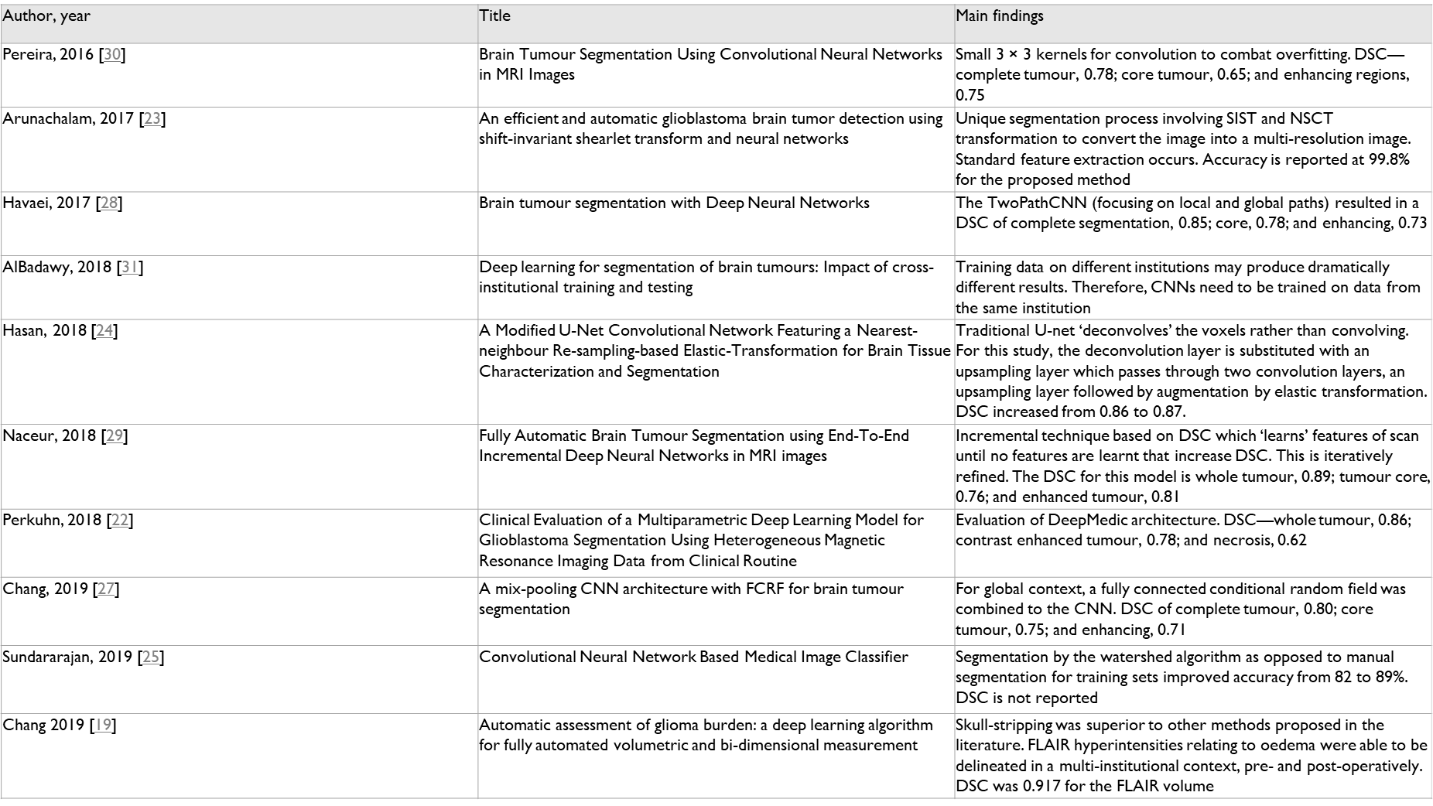

**Proposed work:**

* The purpose of the paper is to provide an efficient algorithm that detects phase III and IV brain tumours of WHO through using deep convulotional neural networks at an faster and accurate than other existing deep learning models that have been implemented.
* Several data post-processing techniques to fine tune the segmentation predictions with CRF, but did find it benecial (it helped for some images, but made some other image segmentation results worse).
* Increasing the network depth further did not improve the
* performance, but increasing the network width (the number of features/lters)
* consistently improved the results.

-The main reason for this paper in detection of brain tumors is to provide aid to clinical diagnosis

**Functional & non-functional requirements**

* The functional requirements in our system are divided into different type of functional according on actors who using our system. We have one actor using our Medical Image Processing system (User). The points below describe all functional requirements for user:
* The usershall be able to select MRI scan images for patients.
* The usershall be able to upload MRI scan images for patients.
* The usershall be able to view segmentation results.
* The user shall be able to view brain tumor detection
* We will describe here the non-functional requirements for our system:
* Usability: The proposed systems easy to use for user.
* Performance: The proposed system is working harmoniously and hierarchically for MRI scan images for different patients, and for the accuracy of result for brain tumor detection.
* Scalability: The capability of proposed system to handle a growing amount of patients and MRI scan images, or its potential to be enlarged in order to accommodate that growth

**SYSTEM DESIGN**

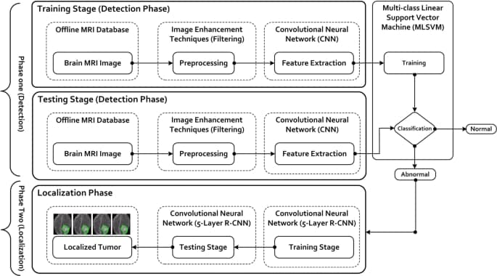

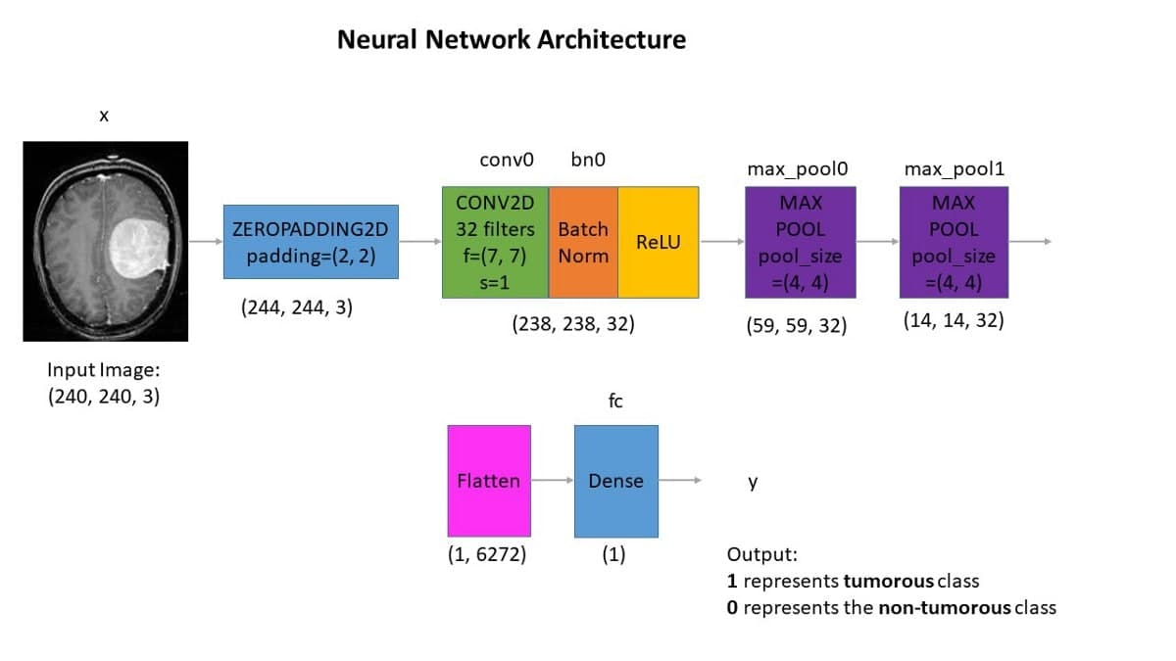

**SYSTEM DESIGN(v2)**

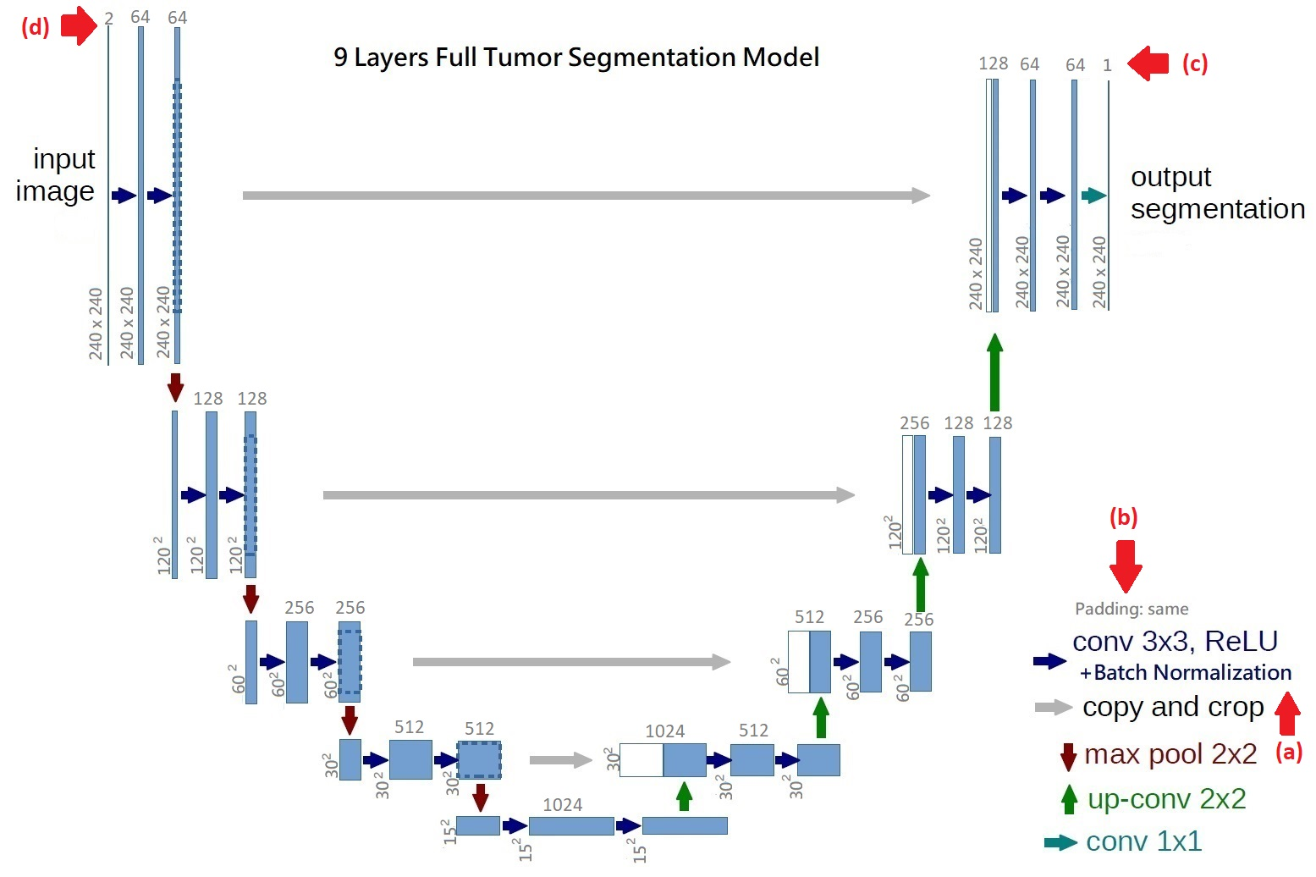

**DATASET**

* BraTS2017
* The MRI images was already skull stripped and resampled to 1mm3 resolution as we got the dataset. No non-uniform intensity normalization algorithm or non-parametric algorithm has been used to correct for intensity non-uniformities caused by the inhomogeneity of scanner’s magnetic field, because it will be obliterated the T2-Flair signal. We use SimpleITK. to read the NIFTI format data. and covert to numpy array format. The data size of each subject is 240x240x155, we only pick the 60-120th axial slices as training data due to the rest part of brain is very unlikely to have any tumor. The slices are then zero-mean normalized using the mean and standard deviation.

**Graphical presentation for comparing existing works ‘results'**

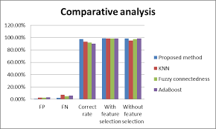

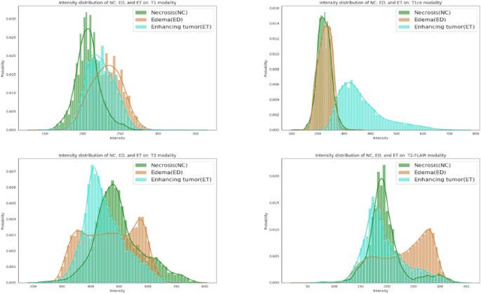

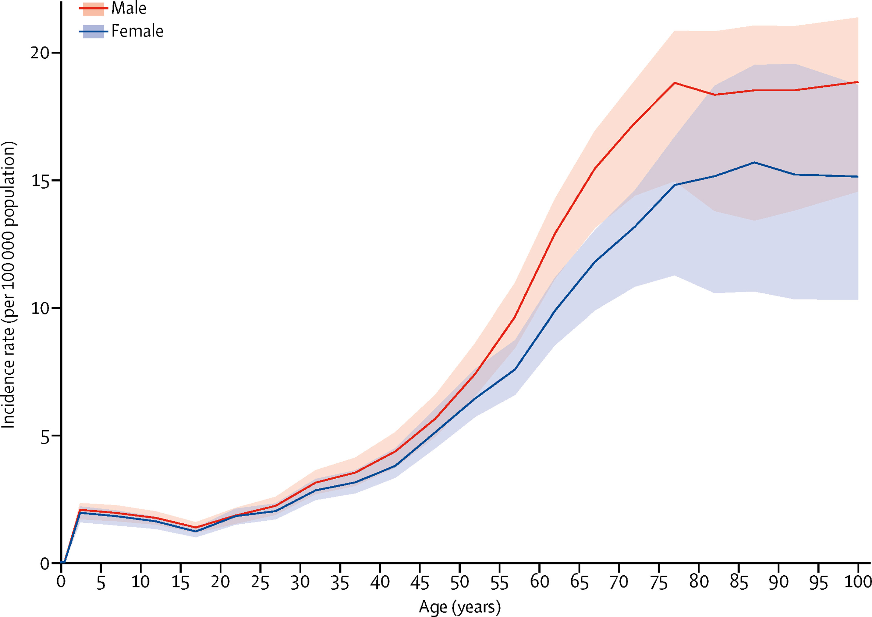

Five different threshold segmentation based approaches have been reviewed and compared over here to extract the tumor from set of brain images

comparison of five semi-automated methods have been undertaken for evaluating their relative performance in the segmentation of tumor. Consequently, results are compared on the basis of quantitative and qualitative analysis of respective methods.

**Time line diagram for the proposed work**

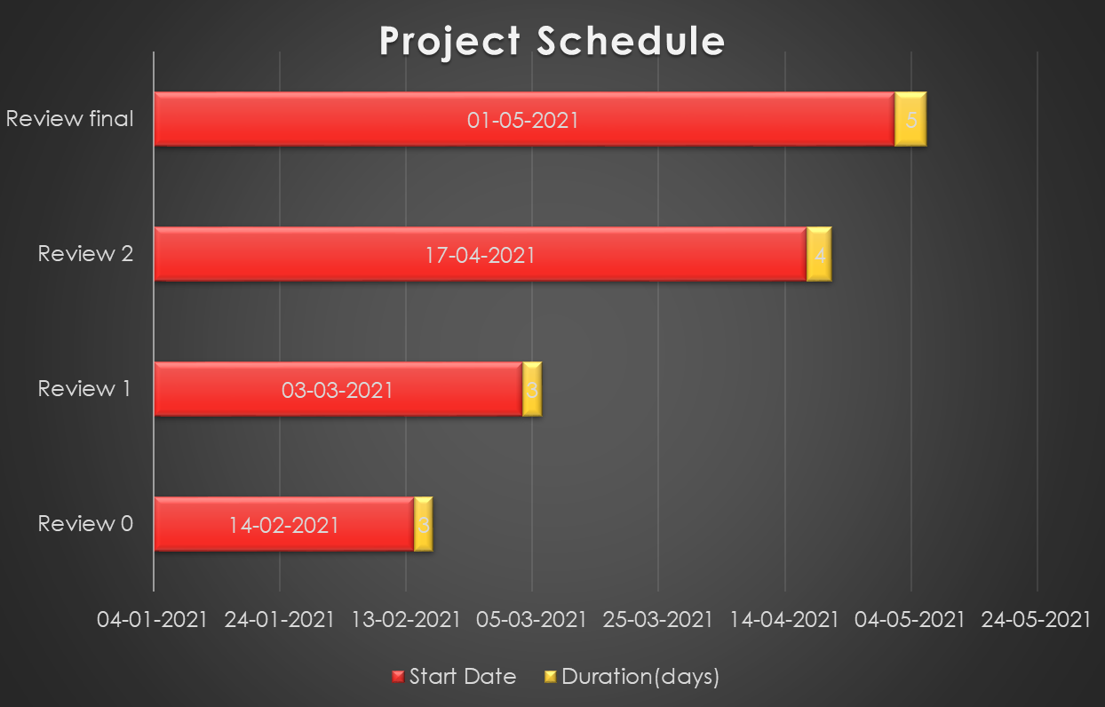

**REFERENCES**

[1]. Mircea Gurbin, Mihaela Lascu, Dan Lascu, “Tumor Detection and Classification of MRI

Brain Image using Different Wavelet Transforms and Support Vector Machines”, 2019 42nd

International Conference on Telecommunications and Signal Processing (TSP), Budapest,

Hungary, 2019, pp. 505-508.

[2]. M. Rezaei, H. Yang, C. Meinel, “Instance Tumor Segmentation using Multitask

Convolutional Neural Network”, 2018 International Joint Conference on Neural Networks

(IJCNN), Rio de Janeiro, 2018, pp. 1-8.

[3]. Harshini Badisa, Madhavi Polireddy, Aslam Mohammed, “CNN Based Brain Tumor

Detection”, International Journal of Engineering and Advanced Technology (IJEAT), Volume-

8 Issue-4, April 2019, pp. 1731 – 1734.

[4]. MB Bramarambika, Seshashayee, “Brain Tumor Detection and Identification Using

Histogram Method”, International Journal of Innovative Technology and Exploring

Engineering (IJITEE), Volume-8 Issue-10, August 2019, pp. 3517 – 3521.

[5]. Tonmoy Hossain, Fairuz Shadmani Shishir, Mohsena Ashraf, MD Abdullah Al Nasim,

Faisal Muhammad Shah, “Brain Tumor Detection Using Convolutional Neural Network”, 1st

International Conference on Advances in Science, Engineering and Robotics Technology 2019

(ICASERT 2019), Dhaka, Bangladesh, 2019, pp. 1-6.

[6]. N. Varuna Shree, T.N.R. Kumar, “Identification and classification of brain tumor MRI

images with feature extraction using DWT and probabilistic neural network”, Brain Inf. 5, pp.

23–30 (2018), https://doi.org/10.1007/s40708-017-0075-5

[7]. M Malathi, P Sinthia, “Brain Tumour Segmentation Using Convolutional Neural Network

with Tensor Flow”, Asian Pacific journal of cancer prevention, APJCP (2019), DOI:

10.31557/APJCP.2019.20.7.2095

[8]. J. Seetha, S. Selvakumar Raja, “Brain Tumor Classification Using Convolutional Neural

Networks”, Biomedical & Pharmacology Journal, September 2018, Vol. 11(3), p. 1457-1461.

[9]. M. Usman Akram, Anam Usma, “Computer Aided System for Brain Tumor Detection and

Segmentation”, International Conference on Computer Networks and Information Technology,

Abbottabad, 2011, pp. 299-302.

65

[10]. Varun Totakura, Mohana Krishna Janmanchi, Durganath Rajesh, M.I. Thariq Hussan,

“Prediction of Animal Vocal Emotions Using Convolutional Neural Network”, International

Journal of Scientific & Technology Research, Volume 9, Issue 2, pp. 6007-6011.

[11]. H. Ucuzal, Ş. YAŞAR and C. Çolak, "Classification of brain tumor types by deep learning

with convolutional neural network on magnetic resonance images using a developed web-based

interface," 2019 3rd International Symposium on Multidisciplinary Studies and Innovative

Technologies (ISMSIT), Ankara, Turkey, 2019, pp. 1-5, doi: 10.1109/ISMSIT.2019.8932761

Işın A, Direkoğlu C, Şah M (2016) Review of MRI-based brain tumor image segmentation using deep learning methods. Procedia Computer Science 102:317–324

Fukushima K (1980) Neocognitron: a self organizing neural network model for a mechanism of pattern recognition unaffected by shift in position. Biol Cybern 36:193–202

Training and Assessment Reform for Clinical Radiology. RANZCR ASM 2019 Conference. Auckland, 2019.

Aerts HJ (2016) The potential of radiomic-based phenotyping in precision medicine: a review. JAMA Oncol 2:1636–1642

Sørensen TJ (1948) A method of establishing groups of equal amplitude in plant sociology based on similarity of species content and its application to analyses of the vegetation on Danish commons. I kommission hos E. Munksgaard

https://www.sciencedirect.com/science/article/pii/S187705091632587X

https://paperswithcode.com/paper/brain-tumor-segmentation-with-deep-neural

https://paperswithcode.com/paper/3d-mri-brain-tumor-segmentation-using

https://paperswithcode.com/paper/one-pass-multi-task-networks-with-cross-task

https://paperswithcode.com/paper/one-pass-multi-task-networks-with-cross-task

https://paperswithcode.com/paper/automatic-brain-tumor-segmentation-using-1

https://www.frontiersin.org/articles/10.3389/fnins.2019.00810/full

https://academicjournals.org/article/article1379596064_Karnan%20and%20Logeswari.pdf

https://link.springer.com/article/10.1007/s11548-020-02186-z#Sec9

<https://www.degruyter.com/document/doi/10.1515/jisys-2017-0027/html>

* RSNA (2018) Artificial Intelligence. Machine LearningRSNA News, RSNA
* Jin KH, McCann MT, Froustey E, Unser M (2017) Deep convolutional neural network for inverse problems in imaging. IEEE Trans Image Process 26:4509–4522
* Yamashita R, Nishio M, Do RKG, Togashi K (2018) Convolutional neural networks: an overview and application in radiology. Insights Imaging 9:611–629
* Angulakshmi M, Lakshmi Priya GG (2017) Automated brain tumour segmentation techniques— a review. Int J Imaging Syst Technol 27:66–77
* Zaidi H, El Naqa I (2010) PET-guided delineation of radiation therapy treatment volumes: a survey of image segmentation techniques. Eur J Nucl Med Mol Imaging 37:2165–2187
* Aslam A, Khan E, Beg MS (2015) Improved edge detection algorithm for brain tumor segmentation. Procedia Computer Science 58:430–437
* Lin G-C, Wang W-J, Kang C-C, Wang C-M (2012) Multispectral MR images segmentation based on fuzzy knowledge and modified seeded region growing. Magn Reson Imaging 30:230–246
* Pandav S (2014) Brain tumor extraction using marker controlled watershed segmentation. IJERT 2278–0181
* Bauer S, Seiler C, Bardyn T, Buechler P, Reyes M (2010) Atlas-based segmentation of brain tumor images using a Markov random field-based tumor growth model and non-rigid registration. Conf Proc IEEE Eng Med Biol Soc 2010:4080–4083
* Komori T (2017) The 2016 WHO classification of tumours of the central nervous system: the major points of revision. Neurol Med Chir (Tokyo) 57:301–311